Simple Stars – LP
Materials:
- 5 Withies cut to 36cm lengths
- Masking tape
- 5 x White cable ties - 45 x 200mm (Screwfix item no: 62734.)

Making:
- Cut the five withies into 36cm lengths avoiding bends at thick end.
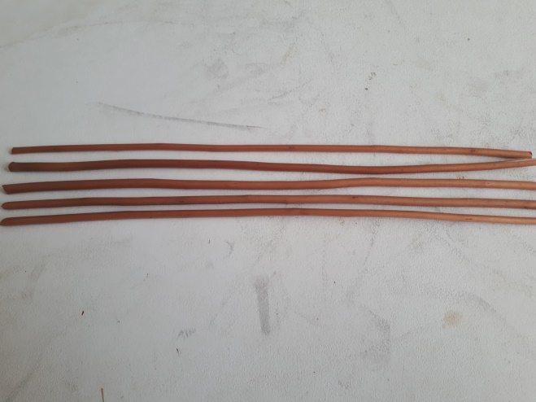
- Tape two withies together with 6-7cm piece of masking tape to make a point. (Leave masking tape extending over the ends of withies and twist to secure.) Make two of these.
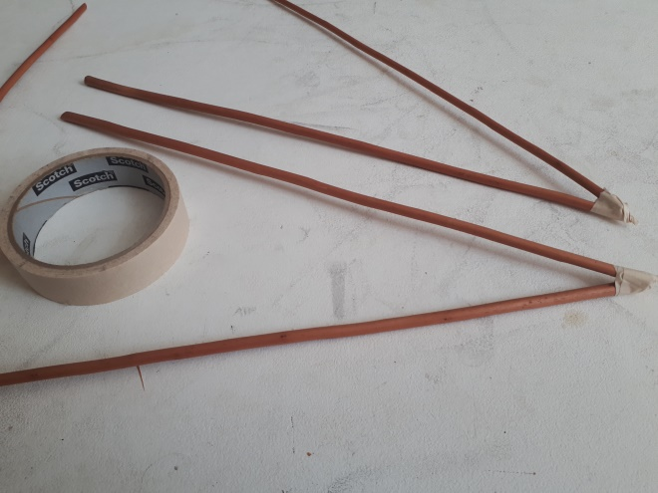
- Tape one end of the remaining withie at one end.
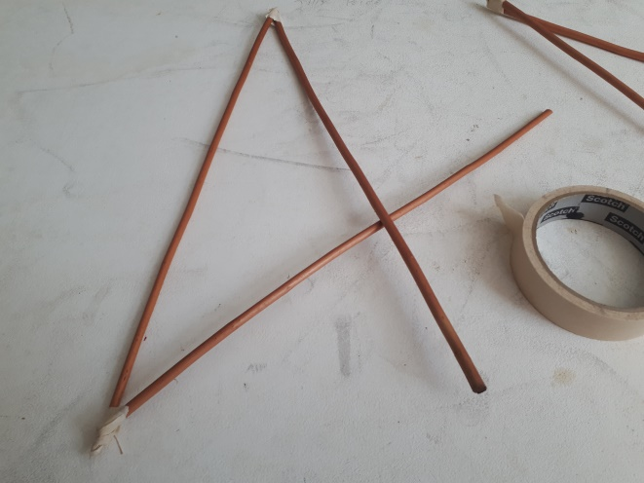
- Attach the second ‘V’ point with masking tape.
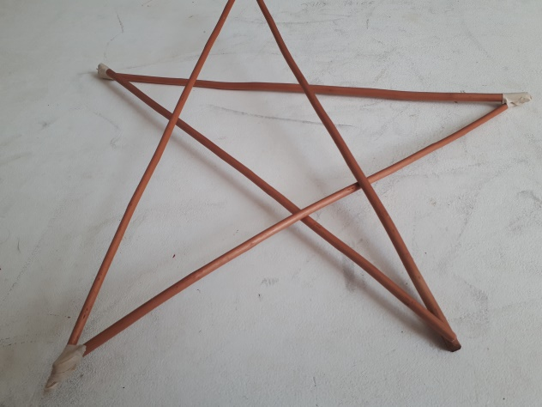
- Adjust the star shape and use five cable ties to secure the central joints.
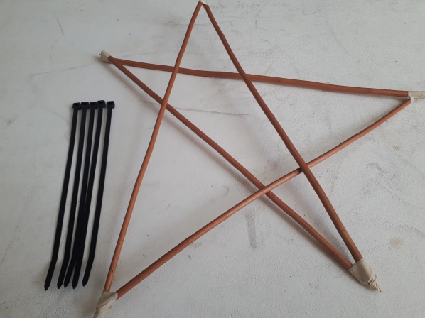 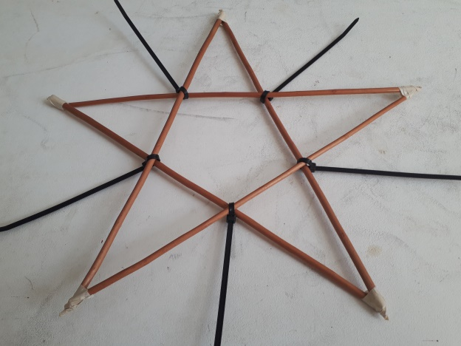
Leave the cable ties uncut to make Star rays. (White cable ties would be better.)

Lighting
Materials:
- 3m EL Wire + 2 x AA batteries.
- Selotape
- Small white cable ties (2.5 x 100 mm).

- Start at one point of the Star. Disconnect battery pack from EL wire, taking care of the tiny plug connector. Use one of the wire tags from the coiled EL wire to temporarily attach it to the star as shown. The black portion should be left hanging free.
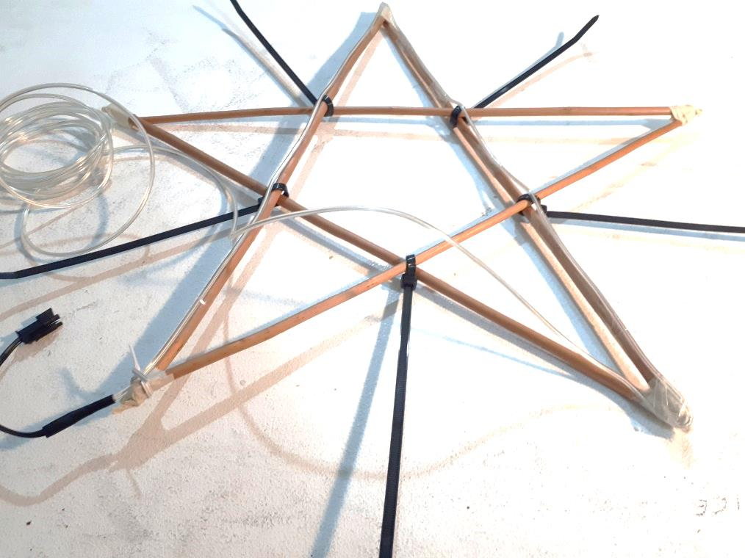
- Selotape the the El Wire to the first stick of the star. Use pieces of 5 cm Selotape.
- Continue taping the EK wire down the second stick as shown. Make sure the corner points are securely taped and keep the EL wire on top of the Star frame.
- Continue selotaping the EL wire to the remaining three sticks.
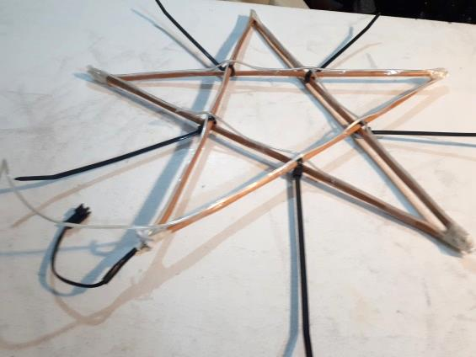
- Remove the temporary wire tie and tape the bottom joint.
You will have at least 1M of spare EL wire to improvise with.

- Check all tape joints and test lights. (take care with the tine plug connector.)
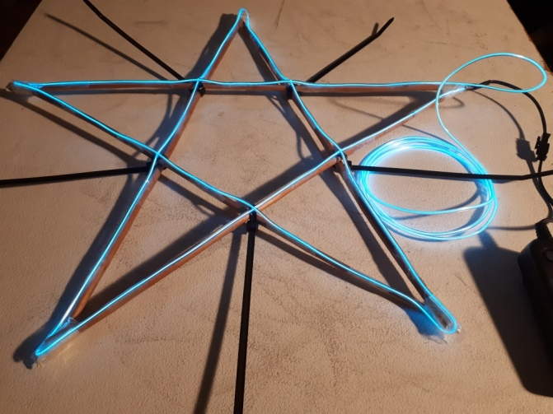
- The EL wire has a natural coil so it’s easy to make a series of small circles as a star trail just using small pieces of Selotape. Ensure that you gaffa the black lead from the El wire where it goes down to the battery pack.
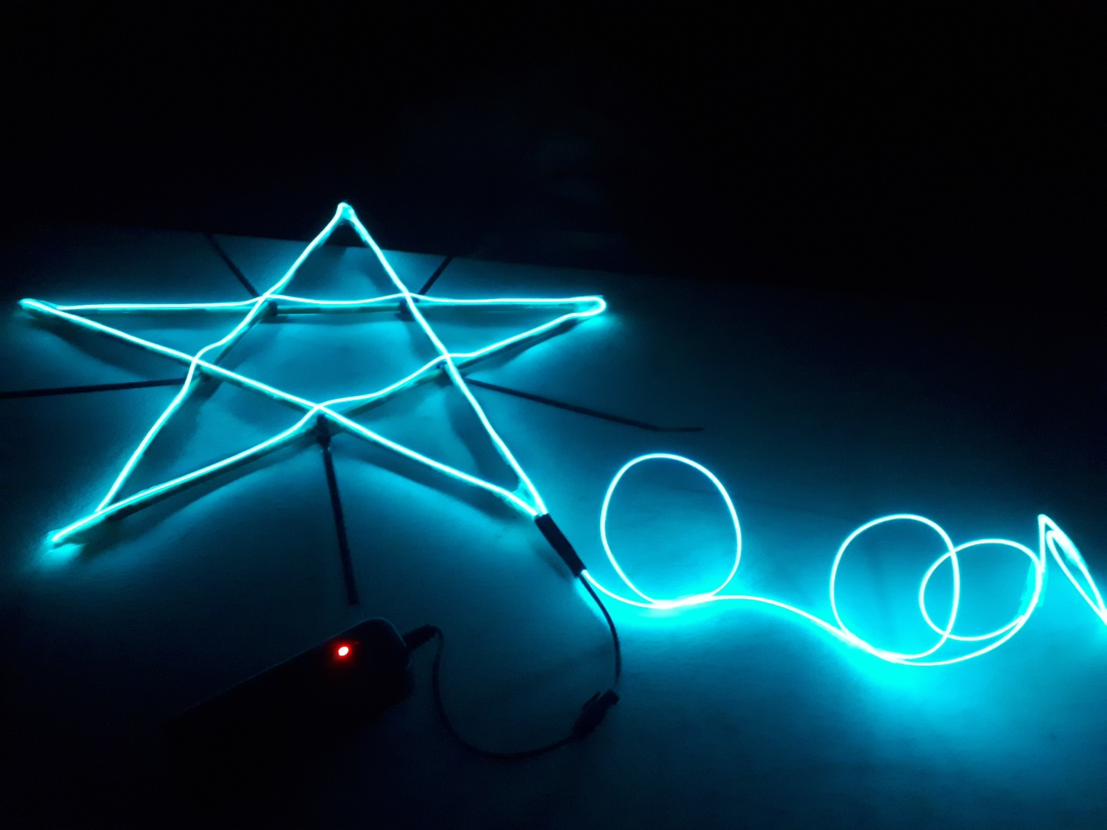
- Cover bamboo with 20cm strips of black Gaffa.
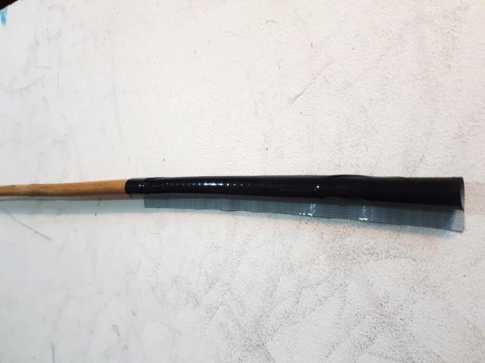
- Attach star to thin end of bamboo with 2 Black cable ties (4.5 x 200mm). Carefully slide the cable tie under the EL wire between the withie and secure around the bamboo. Cut off the 2 cable tie ends.
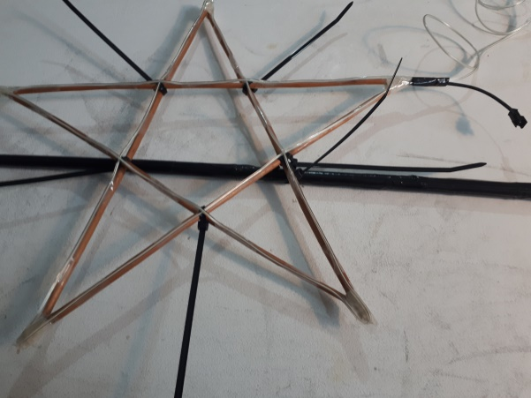 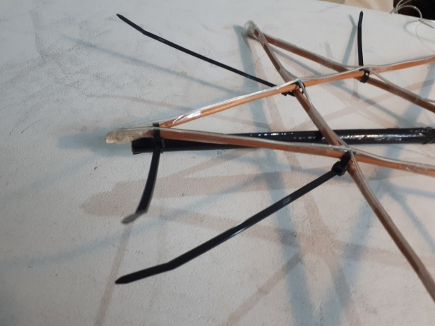
Note:
It is essential the connector socket for the EL wire is here.

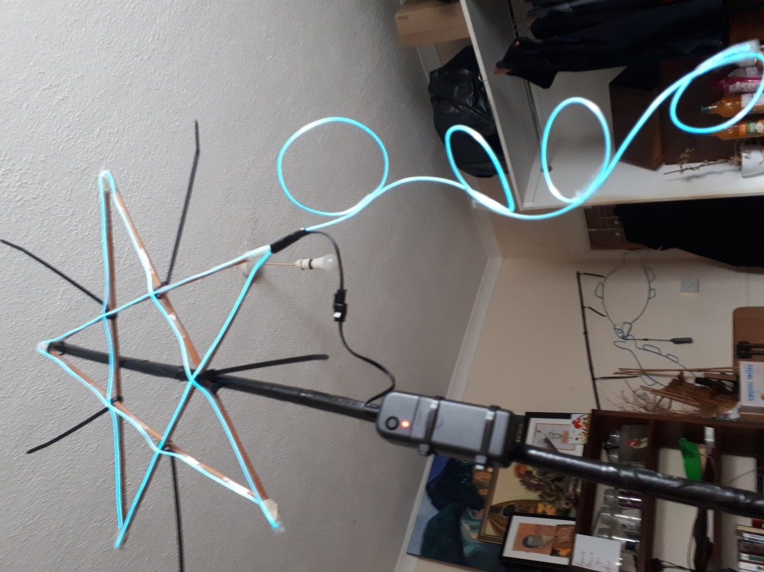
- Cable tie the battery pack onto the bamboo ensuring there is sufficient lead to connect to the EL wire. Cut off ends of the 2 cable ties.
