Star on Cycle Helmet

You will need:
- Tape
- Scissors and pliers
- Withies or garden wire
- Ruler and marking pen
- EL wire and 2 x AA Batteries
- Cable ties

42cm
22cm
20cm
8.4cm

- Measure and mark the withies and cut to length. (2 x 42cm and 3 x 22cm). It’s helpful if you mark the 8.4 cm lengths for assembling the star.
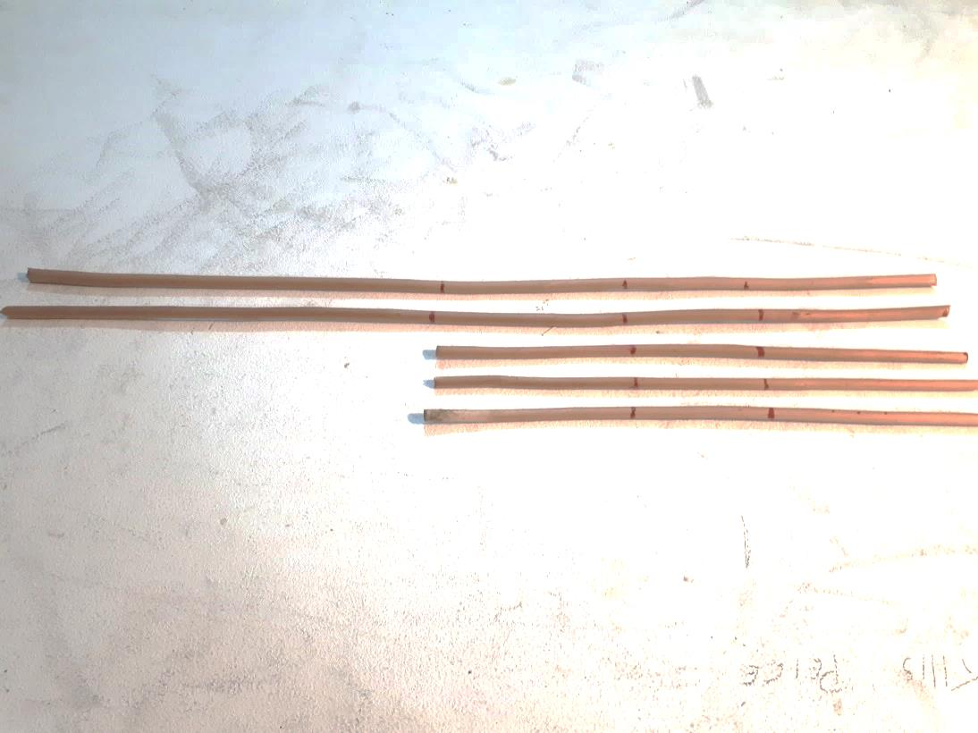
8.4cm
8.4cm
22cm
20cm
42cm

- Join the withies with 5cm pieces of masking tape to make the star.

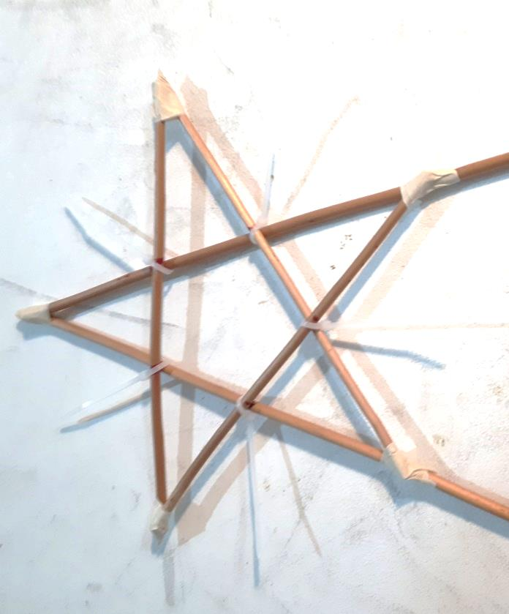
Start at the top point with the two longer pieces.
Tape the three shorter pieces of withies
Pinch the tape tightly around the withies and twist the ends of the masking tape into a point.

Use small white cable ties to secure the middle of the star and make rays.

- Attach the two longer withies to the helmet with Black Gaffa tape. Secure with strong black cable ties.
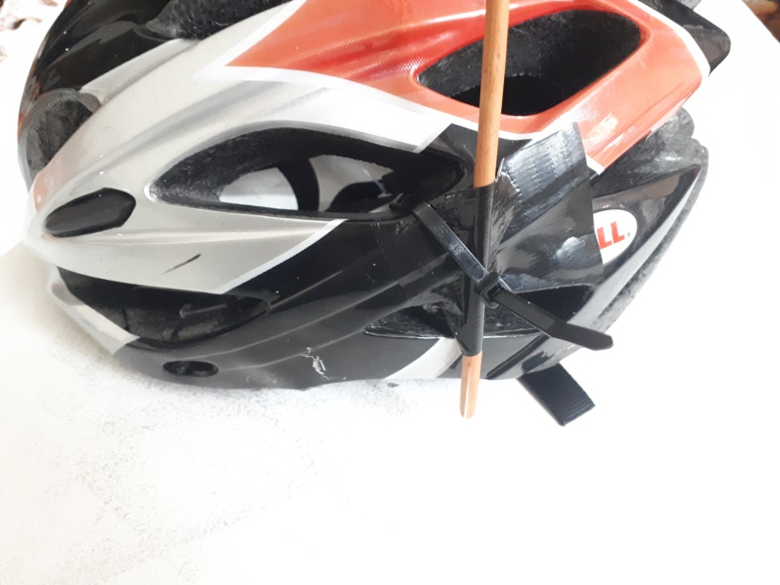
- Unplug the battery back from the EL Wire and insert 2 x AA batteries. (Take care of the plug and socket connection). Attach the battery pack to the rear strap of the helmet with two thick cable ties.
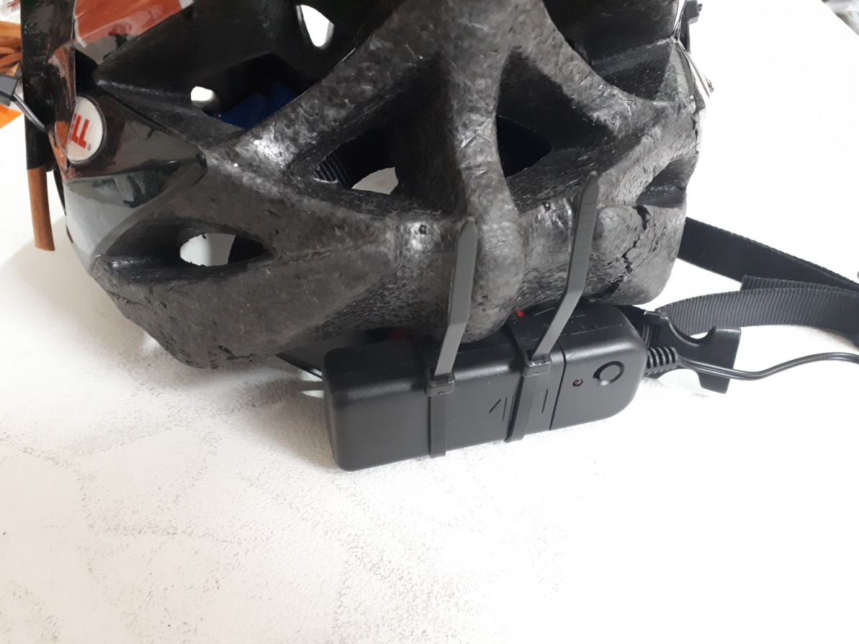

- Attach the plug end of the EL wire to the bottom of the star as shown. Use small white cable ties and/or Selotape.
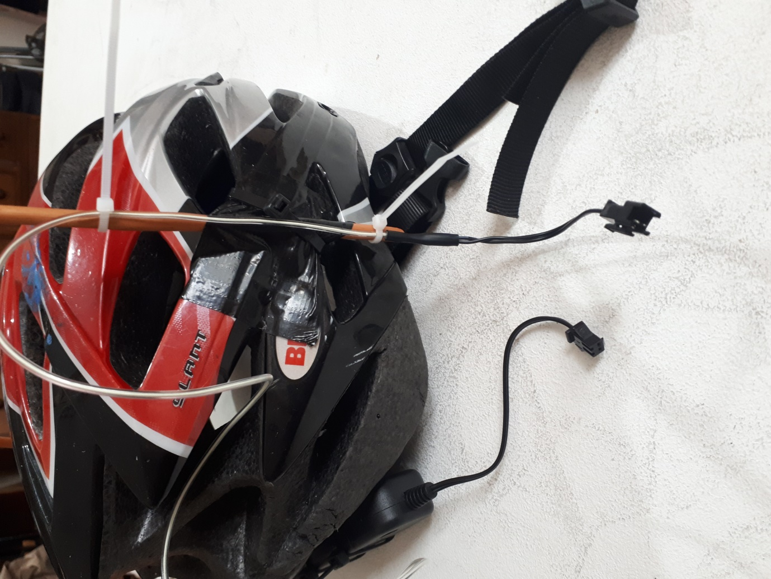
- Continue taping the EL wire up the first leg of the Star to the top. (Selotape)

- Pinch the EL wire into a point at the top of the Star and secure with Selotape or small white cable tie.

- Tape the EL wire down the second long length of the Star to the bottom of the helmet.

- Cable tie the EL wire around the back of the helmet to where you started.

- Tape the El Wire to the rest of the star.
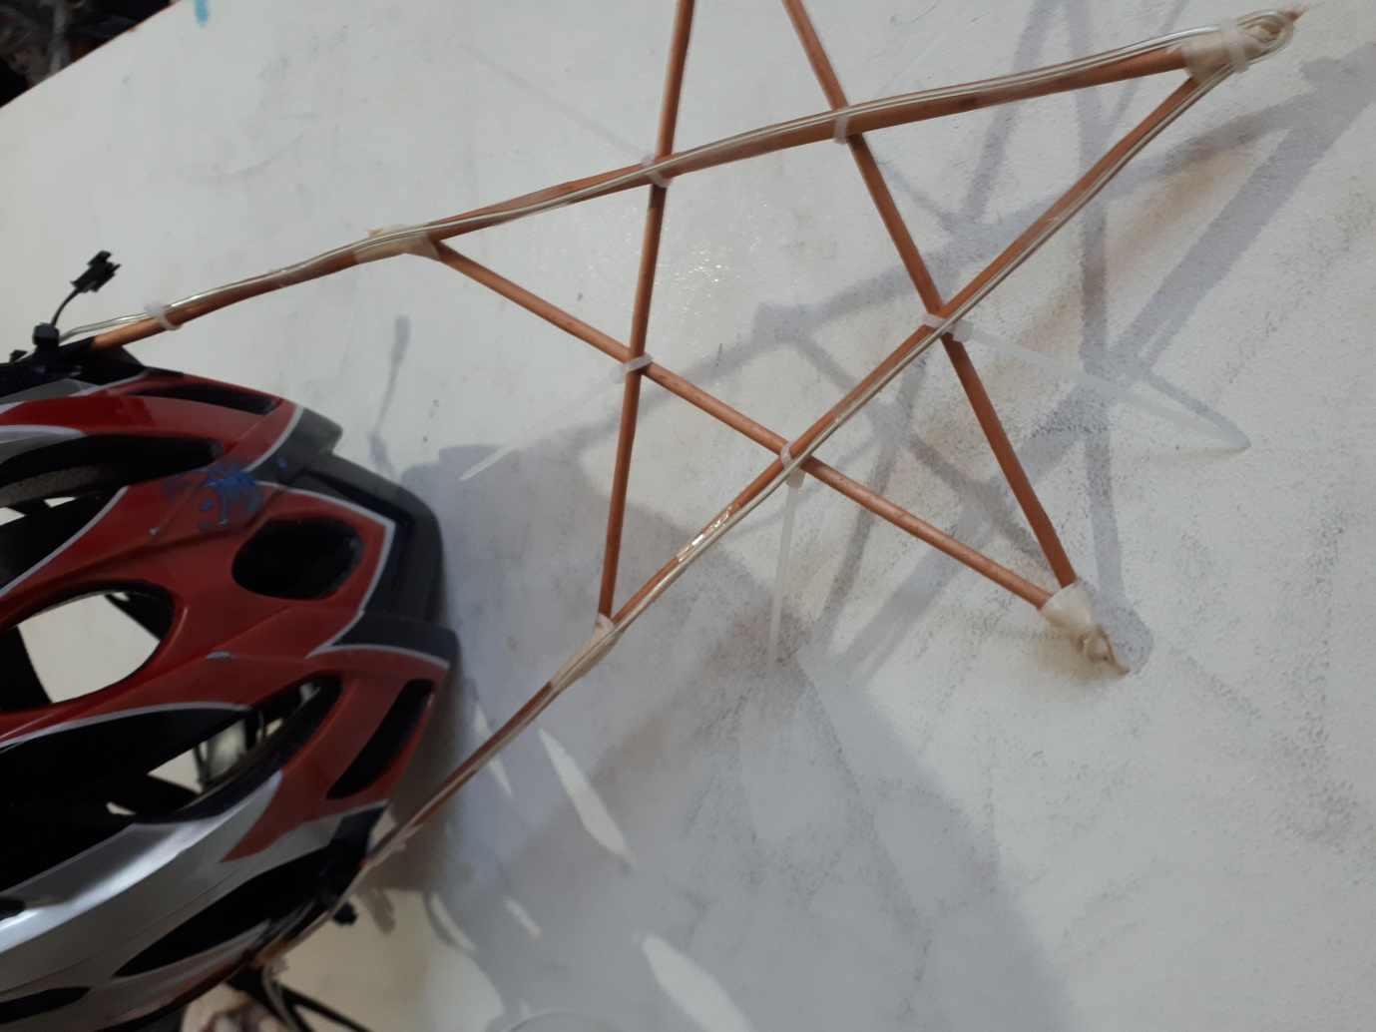

Finish
Start
EL Wire will be doubled
on both of the long Star legs.

- Improvise with any remaining EL wire. I’ve just done a simple circle and attached it to the rear of the helmet. You could do shooting star trails etc.
